**PREDICTIVE MAINTENANCE OF INDUSTRIAL MOTORS**

**INTRODUCTION:**

**OVERVIEW:**

In the recent years use of wireless technology is increasing for the need of upholding various sectors. In these years IOT groped most of industrial area specially automation and control. Industrial motor maintenance plays a key role in its operation. For proper working conditions, the equipment is continuously observed for its temperature, humidity in the environment and any vibration in its operation. Predictive maintenance consists of detecting the operation conditions of the motor at full load and under the effective temperature and wetness conditions while working. This is in contrast to regular methods where values are collected by starting the stationary machine. This way, you can monitor, remotely or otherwise, the operation conditions of critical motors. You can simply connect the motors with the control unit positioned on a machine board using portable instrument. This will allow you to offer better technical support and prevent motor failure before it occurs. By having this knowledge of values, you can carefully and accurately predict when the equipment might fail. This further helps in preventing that failure on time.

**PURPOSE:**

Predictive maintenance (PdM) is a technique to predict when equipment might fail so that the component can be replaced before the failure. Predictive maintenance aims to prevent the occurrence of failure by performing maintenance. It helps in averting unplanned and unnecessary downtime that can affect the company.

**LITERATURE SURVEY:**

**EXISTING PROBLEM:**

Static and dynamic testing of electric motors is critical for successful implementation of predictive maintenance programs. Static testing is the most effective means of measuring the integrity of the motor’s insulation system, and can be used as well for quality assurance when a motor is out of service. Dynamic testing provides valuable information about motor systems, including power condition, load, and the motor, including physical aspects that can affect the life or operation of the motor. Online motor monitoring adds the dimension of gathering motor system health data at regular intervals throughout a day, 365 days a year. Combined, they present a comprehensive picture of motor and motor system health that can be a foundation for successful predictive maintenance programs. They provide the full spectrum of motor condition information required to accurately diagnose and predict imminent failures and as a result solidify electrical motor testing’s place as an essential part of a complete predictive maintenance program.

**PROPOSED SOLUTION:**

Usually, industries have the vast majority of their condition monitoring programs based on the mechanical parameters analysis. The most common methods applied are: Vibration Analysis, Acoustical Analysis, Shock Pulse and Speed Fluctuations.

**THEORETICAL ANALYSIS:**

**BLOCK DIAGRAM:-**

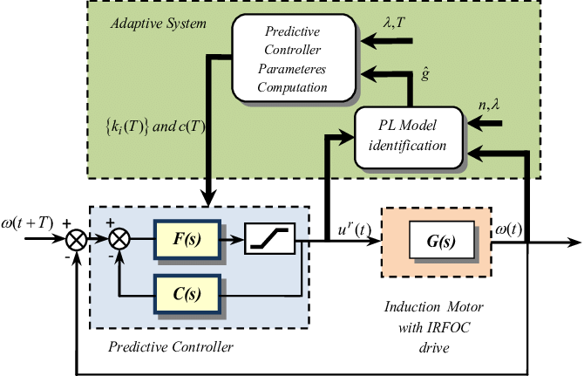

**Experiment investigation:**

Predictive maintenance (PdM) programs are crucial to an organization’s ability to avert unplanned or even unnecessary downtime that can adversely affect its ability to produce or operate. Unlike time-based or run-to-failure approaches to maintenance management, condition-based programs are ideally geared to pay for the cost of implementation by extending the service lives of motors and rotating equipment, averting costly unplanned downtime and minimizing the costs of replacing expensive equipment. Predictive maintenance programs are most effective when all available means of measuring health and analyzing health trends of electric motors, cables, power quality, and load are rigorously implemented.

In other words, safe and continuous operation of plants and facilities drives revenue and profit and depends upon high motor reliability. Predictive maintenance of motor systems is a necessity when it comes to supporting reliability objectives that in turn support business objectives.

**FLOW CHART:**

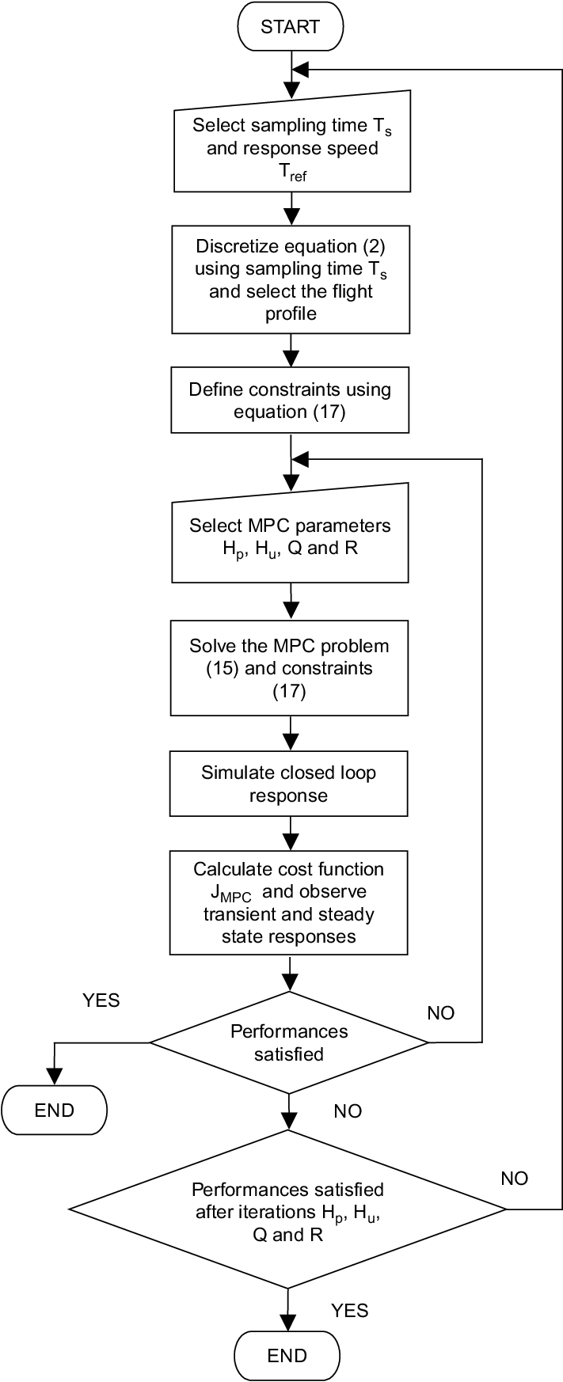

**SOFTWARE DESIGNING:**

In the software designing part create a IBM cloud platform. In this design the raspberry pi model is used .the software should be design by taking a random values and then sent to the IBM cloud services and then the data send to the mobile application which was developed using MIT app inventor.Here we use python language for coding,Node-Red,etc.

**Steps for software designing**

1.Setup Environment

2.Setup Hardware And Develop The Code

3.Building a Web App

**RESULT:**

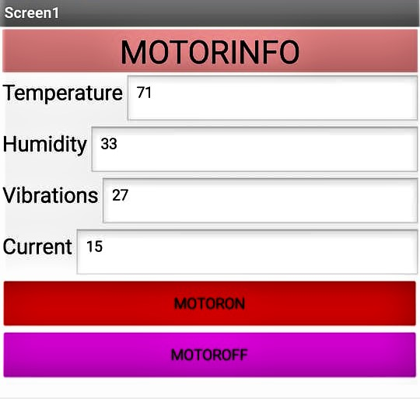

**ADVANTAGES AND DISADVANTAGES OF PREDECTIVE MAINTENAMCE OF INDUSTRIAL MOTORS:**

**ADVANTAGES:-**

**Cost benefits due to increased life:-**You can save money by encouraging predictive maintenance in your facility. Maintenance programs that are time-based or adopt run-to-failure approaches prove to be expensive. Conversely, condition-based programs are geared to pay for the cost of implementation and keep the economic factor in mind. These programs also extend the service lives of motors. All this translates as saved money.

It is critical to involve the company’s management and give them information about costs and benefits derived from predictive analysis and maintenance.

**Reduced down time:-**Since you would be preventing failure before it occurs, you effectively reduce the downtime caused by equipment failure. Predictive maintenance of motors prevents downtime that can be caused by the breakdown of motors.

**Encourages a proactive workforce:-**When you follow the same routine day in and day out, the workers might get complacent. They will stick to the traditional mentality of waiting for the equipment to fail rather than being proactive about prevention.

By introducing a new work method like predictive maintenance, the workforce will be more proactive about preventing electric motor failure.

**Better technical support:-**One way to implement predictive maintenance is through ‘sensoring’ of all the critical positions of drying lines’ fans. This can be achieved by installing fixed sensors, connected in continuous with an external control unit.

This way, you can monitor, remotely or otherwise, the operation conditions of critical motors. You can simply connect the motors with the control unit positioned on a machine board using portable instrument. This will allow you to offer better technical support and prevent motor failure before it occurs.

**Better knowledge of machine’s working:-**Predictive maintenance consists of detecting the operation conditions of the motor at full load and under the effective temperature and wetness conditions while working. This is in contrast to regular methods where values are collected by starting the stationary machine.

By having this knowledge of values, you can carefully and accurately predict when the equipment might fail. This further helps in preventing that failure on time.

**DISADVANTAGES:-**

One of the main disadvantages of predictive maintenance is the amount of time it takes to assess and implement a PdM schedule. With predictive maintenance being a complex initiative, plant personnel must be trained on how to not only use the equipment but also how to interpret the analytics (or data).

While many organizations choose to train existing employees on predictive maintenance, there are condition-monitoring contractors who specialize in performing the required labor and analyzing the results for a facility. In addition to the training costs, predictive maintenance involves an investment in maintenance tools and systems. This cost has decreased over time with the introduction of cloud-based technology.

**APPLICATIONS:-**

* In applications, Predictive Maintenance of industrial motors are used to:
* Help prevent utility outages with the help of drones and sensors that map utility networks.
* Detect a temperature decline in a steam pipeline, indicating a potential pressure leak.
* Capture increased temperatures in electrical panels to prevent component failures.
* Measure supply-side and demand-side power at a common coupling point for monitoring power consumption.
* Locate overloads in electrical panels.
* Identify motor amperage spikes or overheating from bad bearings or insultation breakdowns.
* Find three-phase power imbalances from harmonic distortion, overloads, degradation or failure of one or more phases.

**CONCLUSION:-**

Motor Current Signature Analysis this is an innovative method that allows a

thorough analysis of the condition of the electric motor. The advantage of

this method is that testing is carried out during the normal operation of the

motor and there is no need to stop and interrupt the production process.

In our area, this method is very little represented in the process of electromotor maintenance. However, in the United States it has become a standard in the last few years. The savings that can be achieved by applying

this method in the predictive maintenance of the electric motor have been

recommended as a standard procedure applied in the industry. As it has

become usual for us to measure the vibrations routinely, as a standard

maintenance procedure, MCSA has become the standard method for testing electric motors in the US industry. Producers of advanced MCSA

analyzers are still few and are all from the USA. However, the importance

of this method is becoming increasingly evident in Europe and the manufacturers of these analyzers are slowly turning to our market.

The method of spectral analysis of currents, as a diagnostic method and

tool in predictive maintenance does not exclude the method of vibro-diagnostics. On the contrary, this method compensates for the defects in

vibro-diagnostics in the analysis of complex systems and a good combination of these methods, it is possible to accurately and reliably evaluate

the state of all rotary machines driven by an electric motor.

As vibration measurement has become a widely accepted method for

assessing the condition of mechanical circuits, so will the spectral analysis

method of electric motors to find their place in predictive maintenance. The

confirmation of this is the continuous improvement of advanced analyzers

and the increasing interest of companies, which have so far solely engaged in the production of vibration analyzers, to conquer this technology

and manufacture their own analyzers.

**FUTURE SCOPE:-**

If you could see into the future, you would never miss a production target, endure a safety incident, or have a machine go down. Unfortunately, unless we somehow gain the power of clairvoyance, this fantasy will forever be out of our reach. While we may not be able to see into the future, we can predict it.

By adopting a predictive-maintenance (PdM) strategy, you can mine your critical-asset data and identify anomalies or deviations from their standard performance. Such insights can help you discover and proactively fix issues days, weeks, or even months before they lead to failures. This can help you avoid unplanned downtime, reduce industrial maintenance overspend, and mitigate safety and environmental risks.